Contents

Reservations (ADMIN) 2

Lessons 1-6: Center, Facility Types, Event Types, Prep Codes, Disclaimers, Facilities 2

Lesson 1: Create Centre #1 This is done 2

Lesson 2: Create Facility Types 2

Lesson 3: Create Event Types 3

Lesson 4: Set up Prep Codes 3

Lesson 5: Write a Disclaimer 3

Lesson 6: Develop Facilities for Centre #1 3

Lesson 7-9: Facility Overlaps and Amenities 4

Lesson 7: Assign Facility Overlaps 4

Lesson 8: Create Amenities 4

Lesson 9: Assign Amenities to Facilities 4

Lesson 10-17: Additional Centers and Facilities 5

Lesson 10: Create Centre #2 5

Lesson 11: Develop Facilities for Centre #2 5

Lesson 12: Assign Facility Overlaps 5

Lesson 13: Assign Amenities to Facilities 6

Lesson 14: Create Centre #3 6

Lesson 15: Develop Facilities for Centre #3 6

Lesson 16: Assign Facility Overlaps 7

Lesson 17: Assign Amenities to Facilities 7

Section II: Creating Facility Charges 7

Lesson 1: Create a General Ledger (GL) Account for Facility Rental Fees 7

Preparation: City-wide Facility Charge List 7

Lesson 2: Create Facility Charges: Templates 8

Lesson 3: Create Facility Charges: Implementing Fees 8

# Reservations (ADMIN)

## Lessons 1-6: Center, Facility Types, Event Types, Prep Codes, Disclaimers, Facilities

### Lesson 1: Create Centre #1

*This is likely already created and only needs to be edited.*

**Details:** Create a centre, serving as a self-contained piece of your larger organization

* + Name the centre after a community centre in your city (e.g. Kitsilano Community Centre)
  + Use the following schedule to implement the hours of operation for the centre:
    - Mon – Fri: 6am – 9pm
    - Sat: 10am-6pm
    - Sun 12pm – 5pm
  + Model of centre included below:



* + *Tip: Administration Tab > Locations > Centers*

### Lesson 2: Create Facility Types

**Details:** Develop facility types for your centre – these organize like facilities together for purposes of assigning fees, searching and reporting. Enter capacities as indicated below. Capacities may also be entered at the facility level if all facilities within a facility type do not share the same capacity – which will be used in later lessons.

* + Use the following facility types:
    - Gymnasium (full capacity: 200)
    - Meeting Room Large (capacity: 40)
    - Meeting Room Small (capacity: 20)
    - Swimming Pool (full capacity: 60)
    - Fitness Room (full capacity: 80)
    - Half Gym (capacity: 100)
    - Swimming Lane (capacity: 12)
    - Pavilion Small (Capacity: 10)
    - Pavilion Large (Capacity: 50)
    - Kitchen (Capacity: 5)
* *Tip: Administration Tab > Facility Settings > Facility Types*

### Lesson 3: Create Event Types

**Details:** Develop Event Types for your centre – These describe what type of rentals can occur within the client’s facilities and are used for assigning fees, searching and reporting.

* Note: The list below indicates the event types to implement and the facilities in which each event type can or cannot take place.
* Use the following Event Types:
  + Sports Event (cannot take place in meeting rooms)
  + Special Event (allowed across all facility types)
  + Special Event with alcohol (cannot take place in pool or fitness room)
  + Meeting (cannot take place in pool, gym, or fitness centre)
  + General (allowed across all facility types)
  + Wedding (allowed only in Pavilions, Kitchen and all gymnasiums)
* *Tip: Administration Tab > Facility Settings > Event Types*

### Lesson 4: Set up Prep Codes

**Details:** Create prep codes for set up and clean up times before and after a reservation occurs.  
This does not get billed to the customer.

* Set up prep code: Set Up (30 Minutes)
* Set up prep code: Tear Down (30 Minutes)
* Tip: *Administration > Facility Settings > Prep Codes*

### Lesson 5: Write a Disclaimer

**Details:** A disclaimer is a pre-written message (for example, legal or liability information) that you can attach to facility and equipment reservations/permits and point of sale receipts.

* Type up any disclaimer message
* Tip:*Administration > Facility Settings > Disclaimers*

### Lesson 6: Develop Facilities for Centre #1

**Details:** Create the facilities which the first centre you have created will house

* + Model your facilities, and assign them to your centre based on the picture below
  + Name your facilities to reflect the Centre (e.g. Kits Gym North)
  + ***Note:*** *The full gym, the north and the south gym are three different facilities*
  + Model of the centre with facilities included below:

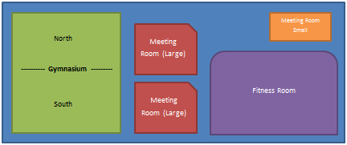

**Kitchen**

Above:   
Pavilion Small 1 Pavilion Small 2 Pavilion Small 3

* + *Tip: Administration Tab > Facility Settings > Facilities*

## Lesson 7-9: Facility Overlaps and Amenities

### Lesson 7: Assign Facility Overlaps

**Details:** Create overlaps and assign them to applicable facilities in your centre

* + Assign facility overlaps to your gymnasium
  + Model your overlaps using the picture below
  + Picture below models centre and shows overlaps in gymnasium:



* + *Tip: Administration Tab > Facility Settings > Facility Overlaps*

### Lesson 8: Create Amenities

**Details:** Develop the amenities which will be available for use across the centres of your organization. Amenities help distinguish between like facilities and can be used for searching.

* + Note: Amenities can be individually assigned to centres/facilities – something that will be covered in the following lesson
  + Use the following amenities:
    - Access to scoreboards
    - Access to Internet
* *Tip: Administration Tab > Facility Settings > Amenities*

### Lesson 9: Assign Amenities to Facilities

**Details:** Assign the amenities created in the above lesson to particular facilities in your centre

* + Assign Internet to the large meeting room
  + Assign scoreboard access to the gymnasium
  + *Tip: Administration Tab > Facility Settings > Facilities*

## Lesson 10-17: Additional Centers and Facilities

### Lesson 10: Create Centre #2

**Details:** Create a second centre to serve as a self-contained piece of your larger organization

* + Name the centre after a community centre in your city (e.g. East Vancouver Community Centre)
  + Use the following schedule to implement the hours of operation for the centre:
    - Mon – Fri: 9am – 10pm
    - Sat – Sun: 10am – 8pm
  + Model of Centre #2 included below



### Lesson 11: Develop Facilities for Centre #2

**Details:** Create the facilities which the second centre you have created will house

* + Model your facilities, and assign them to your centre based on the following picture:

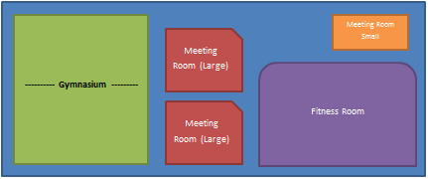

### Lesson 12: Assign Facility Overlaps

**Details:** Create overlaps and assign them to applicable facilities in your centre

* + Assign facility overlaps to your gymnasium
  + Model your overlaps using the picture below:

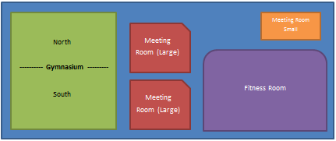

### Lesson 13: Assign Amenities to Facilities

**Details:** Assign the amenities created earlier to particular facilities in your centre

* + Assign Internet to the small meeting room
  + Assign scoreboard access to the gymnasium

### Lesson 14: Create Centre #3

**Details:** Develop a third centre to serve as the final self-contained piece of your larger organization

* + Name the centre after an aquatic complex in your city (e.g. Vancouver Aquatic Centre)
  + Use the following schedule to determine your hours of operation
    - Mon – Fri: 7am – 10pm
    - Sat – Sun: 10am – 9pm
  + A model of the third centre is shown in the following picture:



### Lesson 15: Develop Facilities for Centre #3

**Details:** Create the facilities which the third centre you have created will house

* + Model your facilities, and assign them to your centre based on the picture below:

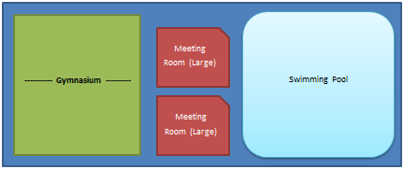

### Lesson 16: Assign Facility Overlaps

**Details:** Create overlaps and assign them to applicable facilities in your centre

* + Assign facility overlaps to your swimming pool
  + Model your overlaps (swimming pool lanes) using the picture below:

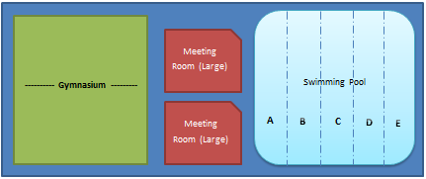

### Lesson 17: Assign Amenities to Facilities

**Details:** Assign the amenities created earlier to particular facilities in your centre

* + Assign Internet to the large meeting rooms
  + Assign scoreboard access to the swimming pool and gymnasium

## Section II: Creating Facility Charges

### Lesson 1: Create a General Ledger (GL) Account for Facility Rental Fees

**Details:** Develop a GL account to serve as a bucket for collecting fees from facility rentals. GL accounts are reported to the organization’s General Ledger and represent how an organization divides up their revenue for year-end reporting.

* Assign appropriate name, number, and type for the GL account
* *Tip: Administration Tab > Financial Settings > GL Accounts*

### Preparation: City-wide Facility Charge List

**Details:** Provided is a list of charges which can be used to implement charges for facility rentals

* Use the following facility charge list included below to complete subsequent lessons
* Note: Fees are based on facility-types and customer-types; they do not vary across different centres

**City-wide Facility Rental Fees**

|  |  |  |
| --- | --- | --- |
|  | **Private Customers** | **Non-profit Customers** |
| **Gymnasiums:** |  |  |
| * Full Gyms (minimum 4-hour) | $200 / hour | $100 / hour |
| * Half Gyms | $100 / hour | $50 / hour |
|  |  |  |
| **Meeting Rooms** | $40 / hour | $20 / hour |
|  |  |  |
| **Swimming Pools:** |  |  |
| * Full Pool (Monday – Friday) | $50 / hour | $50 / hour |
| * Full Pool (Saturday & Sunday) | $75 / hour | $75 / hour |
| * Pool Lanes   **Fitness Rooms**  **Pavilions – Large**  **Pavilions – Small**  **Kitchen** | $10 / hour  $30 / hour  $50/ hour  $25 / hour  $15 / hour | $10 / hour  $30 / hour  $50/hour  $25/ hour  $15 / hour |

### Lesson 2: Create Facility Charges: Templates

**Details:** Using the charge list above, develop facility charge templates to be used later when assigning fees to facilities via the charge matrix

* Note: Charges varying by customer-type will need to be addressed specifically using the Facility Charge Matrix – both types using a fee-generic template
* Note: To enforce a minimum time booking, activate the Advanced Options
* *Tip: Administration Tab > Facility Settings > Charges*

### Lesson 3: Create Facility Charges: Implementing Fees

**Details:** Using the charge list above, implement fees applicable to specific facilities

* Using the Facility Charge Matrix, select the applicable charge template developed in the previous lesson. Ensure to select customer & facility type, the GL account and enter the charge fee. Additional fields will be explored later.
* Note: After specifying customer-type, work upwards from facility level until you are achieve the correct level of granularity. Study the following diagram to understand how ActiveNet applies charges:

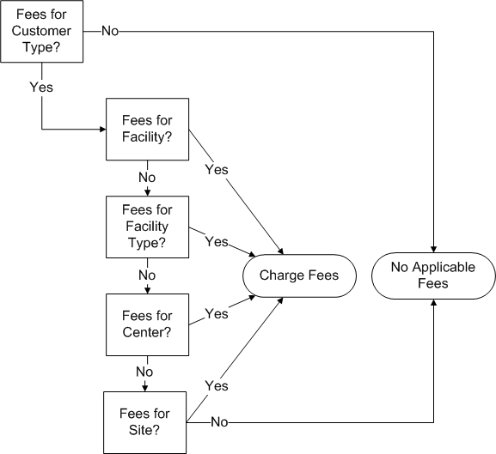

* *Tip: Administration > Facility Settings > Facility Charge Matrix*